CS 255 System Design Document Template

UML Diagrams

UML Use Case Diagram
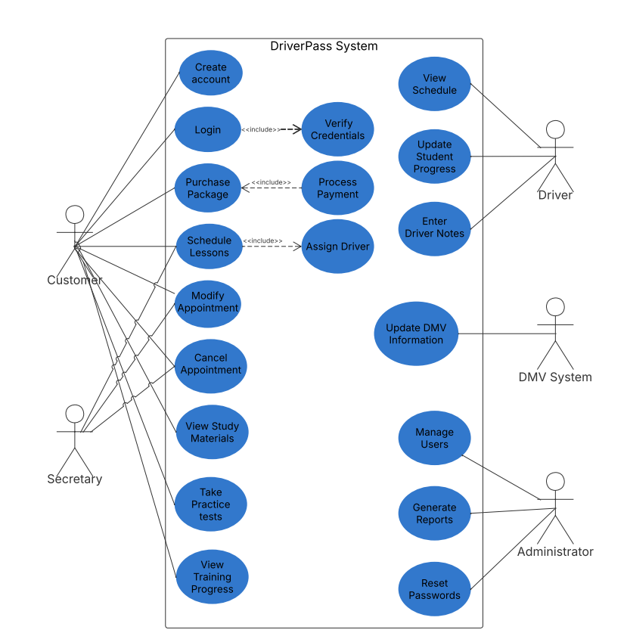

UML Activity Diagrams
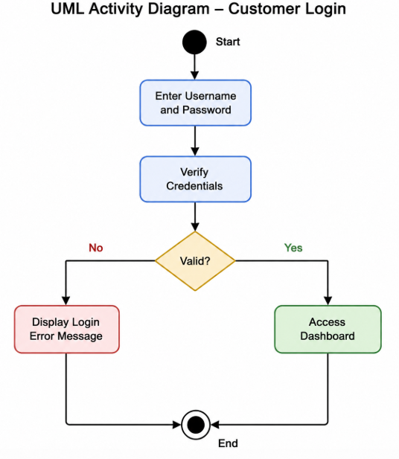
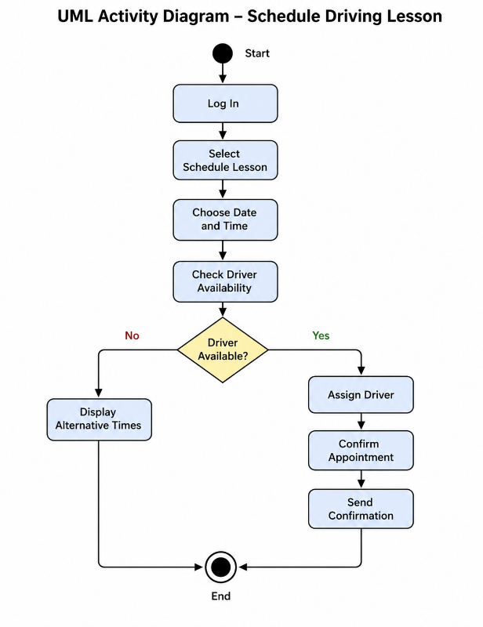

UML Sequence Diagram
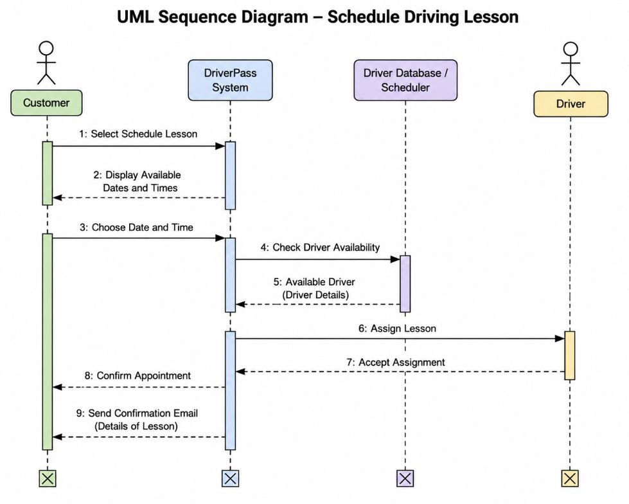

UML Class Diagram
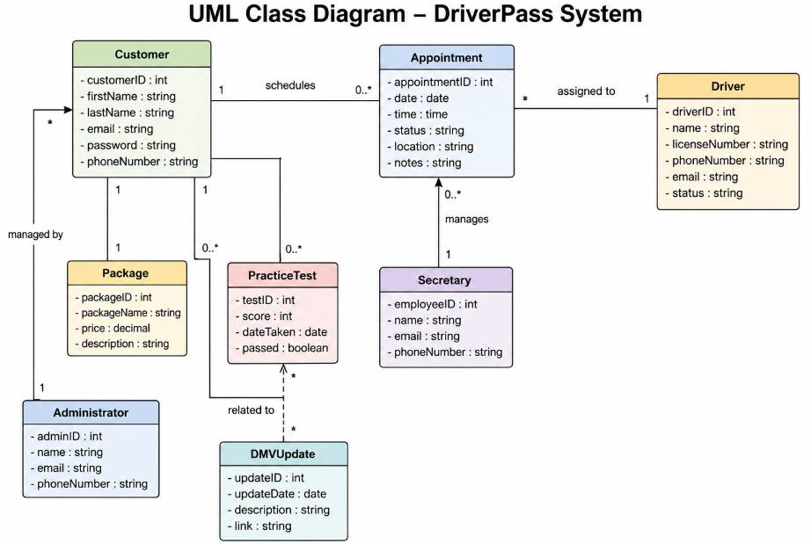

Technical Requirements

The DriverPass system will be a web-based application that allows customers, drivers, secretaries, and administrators to access the system through an internet browser. The system should support common browsers such as Google Chrome, Microsoft Edge, Mozilla Firefox, and Safari. Mobile device access should also be supported to allow users to access the system from various locations.
The system will require a secure cloud-hosted server to provide reliable access and support multiple users simultaneously. Cloud hosting will allow DriverPass to scale the system as the business grows while maintaining availability and performance.
A relational database management system will be required to store customer accounts, appointment schedules, lesson packages, practice test results, payment information, driver assignments, and DMV updates. Regular automated backups should be performed to protect against data loss and support disaster recovery.
Security requirements include secure user authentication, encrypted passwords, role-based access control, and secure payment processing. Customers should only have access to their own information, while secretaries, drivers, and administrators should have access based on their assigned roles. The system should use secure HTTPS connections to protect data transmitted between users and the server.
The system will require integration with external services, including payment processing providers and DMV information updates. These integrations will ensure that customer payments are processed securely and that DriverPass maintains current driving laws, policies, and testing information.
Hardware requirements include cloud servers, employee workstations, internet connectivity, and secure storage systems for database backups. The infrastructure should support future growth and increased customer demand without requiring major system redesigns.

